Dear Swimmer/Parent

As you may be aware Swimming Canada was victim of a cybersecurity incident causing an outage of the Registration, Tracking and Results System (RTR) as of January 16th.

We have relaunched the RTR and Swimming Canada has been working with the Clubs and Provincial Sections to rebuild as much swimmer data as possible.

Upon registration, swimmers or a guardian (if swimmer is under 18) are required to sign the Acknowledgement and Assumption of Risk Form and consent to Swimming Canada/Provincial policies. You are receiving this email because you will need to resign these forms.

Please login to the RTR at the following link: <https://registration.swimming.ca/Login.aspx>

If you do not remember your password please use the password reset feature ensuring that you select “Swimmer Account” from the dropdown list. The email address is the email associated with your swimmer account. If you require assistance please email [support@swimming.ca](mailto:support@swimming.ca) being sure to indicate the swimmer name in your email.

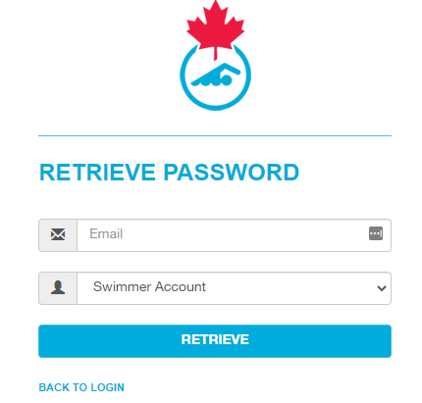

Once logged into the RTR click “Update Account Information”. It is highly recommended that you update your password.

Follow the steps to complete any missing account information and sign the Acknowledgement and Assumption of Risk and any other province specific forms. Once complete, ensure that you click submit to ensure that account information is saved.

For any assistance please contact [support@swimming.ca](mailto:support@swimming.ca)